pm2 start npm --name "SERVER MP2 FORK - int FORK" --watch -- run devFork

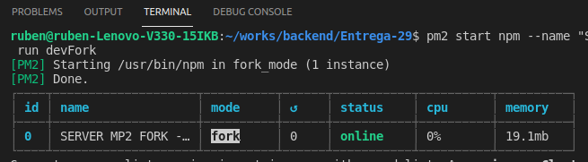
pm2 start npm --name "SERVER MP2 FORK - int FORK" --watch -- run devCluster
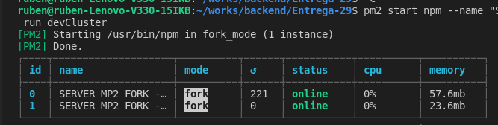
pm2 start npm --name "SVR pm2 CLUSTER-FORK" -i max -- run devFork

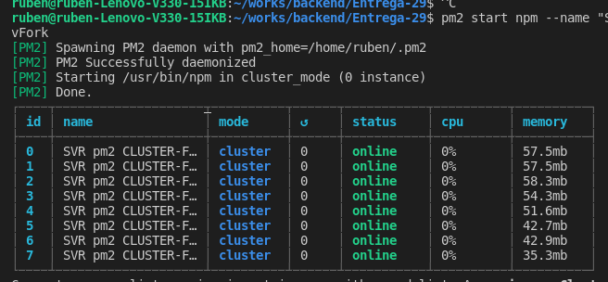

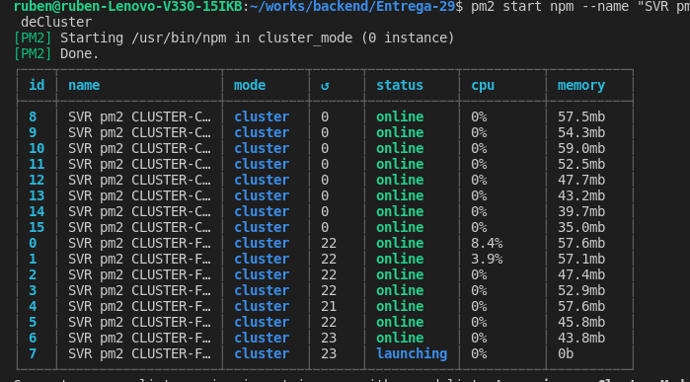
pm2 start npm --name "SVR pm2 CLUSTER-CLUSTER" -i max -- run deCluster

